MINOR PROJECT
FROM DNA SAMPLE TO VERIFIED PCR RESULT

DNA (deoxyribonucleic acid) contains the genetic information of an organism. In molecular biology, researchers often need to isolate DNA from a biological sample before studying a particular gene or DNA region.
A typical workflow is:
Biological sample → DNA extraction → DNA quality check → PCR → Agarose gel electrophoresis → Sequencing → Final verification
Each step has a specific purpose:
- DNA extraction: obtains DNA from cells.
- DNA quantification and quality check: determines how much DNA is present and whether it is sufficiently pure.
- PCR: makes many copies of a selected DNA region.
- Agarose gel electrophoresis: checks whether the PCR produced a DNA fragment of the expected size.
- Sequencing: determines the actual nucleotide sequence and can provide stronger confirmation of the target.
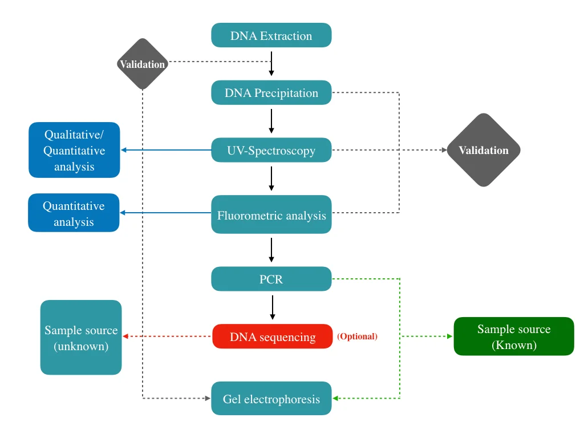
Reference link: https://geneticeducation.co.in/
DNA is present inside cells and is associated with proteins and other cellular components. Biological sample therefore contains much more than DNA like RNA, proteins, lipids, carbohydrates etc which may interfere with techniques such as PCR. Therefore DNA extraction separates DNA from most other cellular components and produces DNA that can be used for downstream experiments.
Reference link: https://www.sciencedirect.com/

- BASIC DNA EXTRACTION WORK FLOW: -
DNA extraction generally involves the following steps:
1. Sample Preparation: A biological sample such as blood, tissue, or cultured cells is collected and prepared for DNA extraction.
2. Cell Lysis: Cells are broken open to release DNA. Lysis also helps break down cellular membranes and proteins.
3. Removal of Contaminants: Proteins, RNA, salts, and other cellular components are removed so that relatively pure DNA remains.
4. DNA Purification: In a silica-column method, DNA binds to a silica membrane, while many contaminants are removed.
5. Washing: The membrane is washed to remove remaining impurities while the DNA stays bound to it.
6. Elution: Finally, purified DNA is released from the membrane and collected in a clean tube.
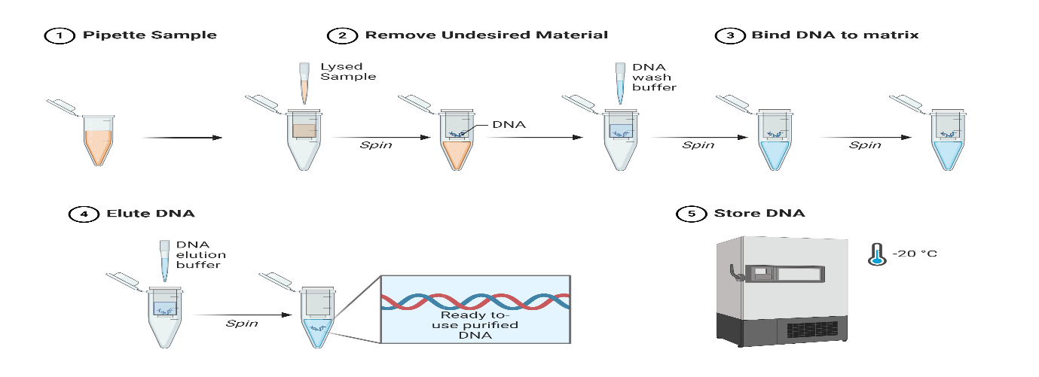
Reference link: https://www.qiagen.com/
After DNA extraction, the DNA is checked for its quantity and purity before PCR.
- A260
- DNA absorbs UV light strongly at 260 nm.
- A260 is used to estimate the amount/concentration of DNA in the sample.

- A280
- Proteins absorb UV light strongly around 280 nm.
- A280 helps detect possible protein contamination.

- A260/A280 Ratio
- This ratio is used to estimate DNA purity.
- Pure DNA generally has an A260/A280 ratio of about 1.8.
- A much lower ratio may indicate contamination, particularly by proteins or phenolic compounds.
Reference link: https://www.thermofisher.com/
- PCR (polymerase chain reaction):
PCR is a technique used to make many copies of a specific DNA region.
PCR requires:
- Template DNA
- Forward and reverse primers
- DNA polymerase
- Nucleotides
- Buffer
PCR occurs in three main steps:
1. Denaturation: The DNA is heated, causing the two strands to separate.
2. Annealing: The temperature is lowered, allowing the primers to attach to their complementary DNA sequences.
3. Extension: DNA polymerase adds nucleotides to the primers and produces new DNA strands.
These three steps are repeated for several cycles, resulting in amplification of the target DNA region.
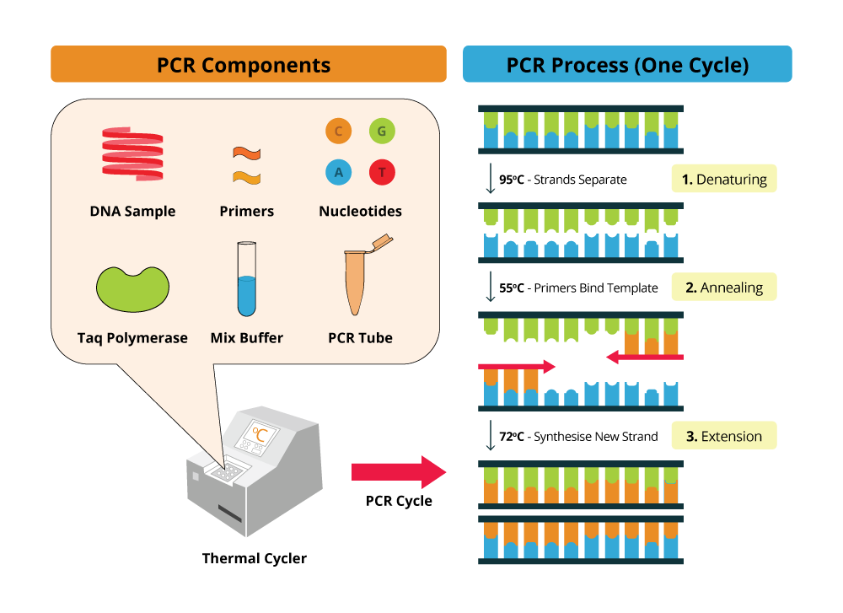
Reference link: https://www.bosterbio.com/
- AGAROSE GEL ELECTROPHOROSIS:
After PCR, we need to determine whether the expected DNA fragment was actually produced. This is where agarose gel electrophoresis is useful. DNA has a negatively charged phosphate backbone. When an electric field is applied across an agarose gel, DNA moves toward the positive electrode. The agarose gel acts like a molecular sieve. Larger DNA fragments move more slowly and remain closer to the wells. After electrophoresis, DNA can be visualized using an appropriate DNA stain and imaging system.
A DNA ladder is a mixture of DNA fragments of known sizes.It acts like a ruler for DNA fragments. For example, if the experiment is designed to amplify a particular region of approximately 500 base pairs, the PCR sample should show a band around the corresponding position relative to the DNA ladder.
- SEQUENCING:
Sequencing determines the exact order of nucleotides (A, T, G and C) in a DNA fragment. After PCR and gel electrophoresis, the amplified DNA can be sequenced to confirm its identity.
- Gel electrophoresis: tells us the approximate size of the DNA fragment.
- Sequencing: tells us the actual DNA sequence.
The obtained sequence can then be compared with the expected/reference sequence to confirm whether the correct DNA region was amplified.
Reference link: https://www.ncbi.nlm.nih.gov/
